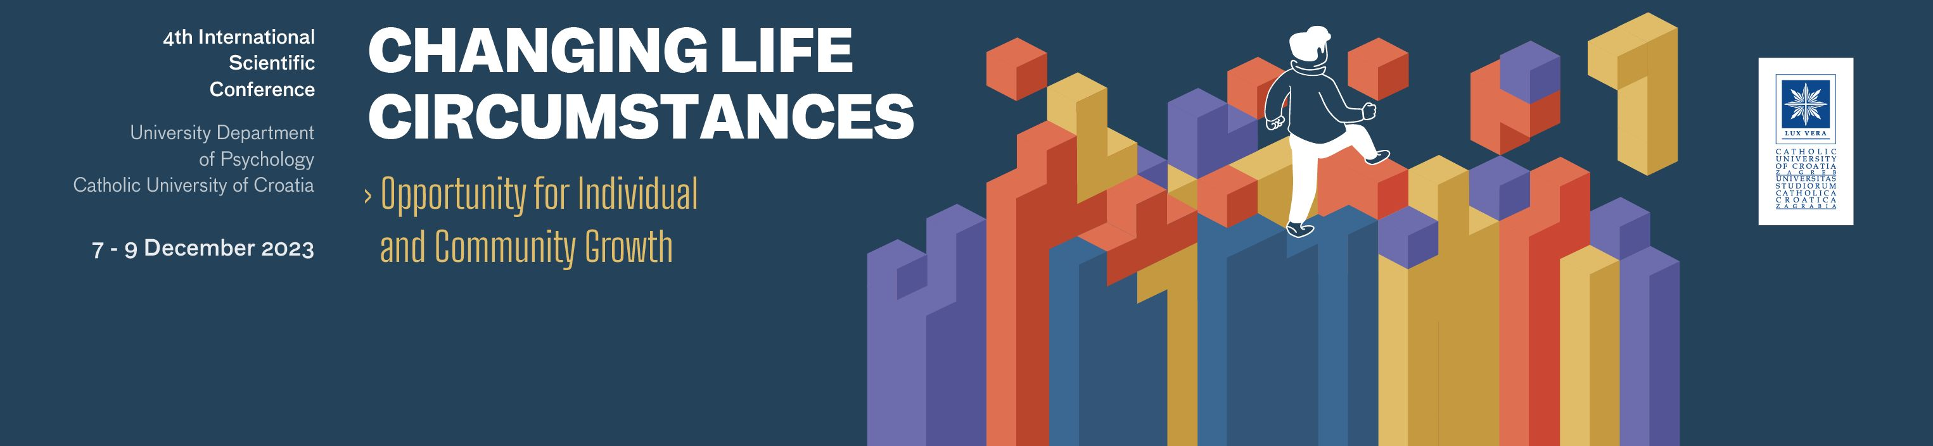

Selected Proceedings
- Guidelines for Manuscript Preparation and Submission –

Dear colleagues,

it is our great pleasure to invite you to submit the full-length manuscripts of your abstracts presented at our 4th International Scientific Conference “Changing Life Circumstances – Opportunity for Individual and Community Growth” in the book of selected proceedings that will be published in English. The deadline for the manuscript submission is 5th April 2024. The manuscripts will undergo double-blind peer review by two independent reviewers and only the best quality manuscripts will be accepted for publication. The decision of the Editorial Board of the manuscripts’ acceptance or rejection will be sent to the authors by the end of July 2024. This decision is final and cannot be appealed. The publication of the Selected Proceedings will be by the end of 2024.

The Editorial Board

The Propositions
- The full-length manuscripts of the same-titled abstracts and the same list of authors can be submitted only.
- Submission of only one manuscript of the same first author is allowed.
- Scientific and professional manuscripts based on empirical research can be submitted (review articles will not be considered for publication). However, due to the limit of the Selected Proceedings length, the scientific manuscripts will be prioritized.
- The manuscripts can be in English only (American or British usage is accepted, but not a mixture of these). The authors are solely responsible for the quality of the language and the Editorial Board reserves the right to refuse the manuscript due to a low level of the language quality.

Submission
- The manuscript submission is electronically via proceedings.psyconf2024@unicath.hr.
- The authors should prepare two files (in .doc or .docx format).

- “Application Form for Manuscript Submission” – which can be downloaded from our website https://www.unicath.hr/conference2023-psychology/selected-proceedings. This file contains all the details about the authors and only the Editorial Board will have access to it.
- The anonymous file containing Title, Abstract, and Manuscript. The reviewers will receive only this file. Please make sure that all identification in the file is removed.

Application form for manuscript submission contains several parts:

- The first part comprises the title (maximum 15 words), abstract (250–300 words), and the keywords (3–5 words). The Abstract should state briefly the background and aim(s) of the research, and describe in brief the method, results and conclusions. The abstract is often presented separately from the article, so it must be able to stand alone. References should be avoided, but if essential, then cite the author(s) and year(s). In addition, non-standard or uncommon abbreviations should be avoided, but if essential, they must be defined at their first mention in the abstract itself.
- The second part comprises the details about the corresponding author and acknowledgements (if applicable). The corresponding author should be only one person who will be in contact with the Editorial Board.
- The third part contains the list of all authors (including the corresponding author) listed in the order of appearance of the authorship. At least one author should be marked as a possible reviewer for other manuscripts submitted to the Selected Proceedings in the field of their expertise.
- The final part contains the list of potential reviewers for the submitted manuscript. This is a mandatory part of the Application Form, in which two potential reviewers for the manuscript should be listed. The authors are kindly requested not to contact the reviewers themselves.

Guidelines for the Manuscript

- The maximum length of the manuscript is 5000 words (including the References).
- The Abstract should have 250-300 words and include the description of background and aim(s), method, results, and conclusions. The abstract should be followed with 3-5 keywords. (Make sure it is the same as in the Application Form).
- Manuscript sections should include: Introduction, Method, Results, Discussion, References.

- The manuscript can have up to five (5) tables and/or figures. Tables and figures should be used sparsely and should not duplicate the data presented in the text. Please make sure:
  - they are all numbered in order of appearance,
  - they all have titles and/or figure captions,
  - they are self-explanatory, and
  - they are referred to in the text.

- Please insert all tables and figures at the appropriate places in the manuscript. Also, please attach a copy of figure(s) as a stand-alone file in .jpg or .tiff format. File name should be titled with figure number, title, and the author’s last name.
- Please avoid using footnotes.
- Insert page numbers (at the bottom right side) and line numbers (on the left margin).
- Use Times New Roman font 12; 1.5 lines spacing and justified alignment.
- APA 7 style for manuscript preparation (Publication Manual of the American Psychological Association, 7th ed., 2020) should be followed, especially regarding the preparation of the tables and reference style.

Reference list examples:

Journal article:
Paap, K. R., & Greenberg, Z. I. (2013). There is no coherent evidence for a bilingual advantage in executive processing. Cognitive Psychology, 66(2), 232-258. https://doi.org/10.1016/j.cogpsych.2012.12.002

Book:
Foxall, G. R. (2018). Context and cognition in consumer psychology: How perception and emotion guide action. Routledge.*

Book chapter:
Haybron, D. M. (2008). Philosophy and the science of subjective well-being. In M. Eid & R. J. Larsen (Eds.), The science of subjective well-being (pp. 17-43). Guilford Press.*

*Include a DOI after the publisher, if available.

